**Project Report**

**On**

**Theme Park Management System**

Abstract

This project manages people and provides ticket to the person who comes to visits and take ride in theme park with his/her family.

With this project admin is able to see how many people is visiting in park and also see how many ticket is generating in particular period.

**Introduction**

Park Theme Management System is a web based technology which manages people and provides ticket to the person who comes to visits and take ride in park with his/her family. This web application provides a way to effectively control record & track the people who visit to park.

A Theme Park Management system effectively manages and handles all the functioning of a park. The software system can store the data of people tickets that came to visit in the park. The system also maintains and calculates the price of ticket. The system needs an administrator to input the detail of ticket like how many are adult and how many are child and print the ticket and give it to person.

In this project we use PHP and MySQL database and it has only one module i.e. Admin

**Advantages:**

* It helps the park admin to handle and manage ticket data.
* Reduce time consumption.
* Reduce error scope.
* All system managements are automated.
* Centralized database management.
* Easy operations for operator of the system.
* No paper work requirement.

**Disadvantages:**

* The system can only handle Single Park.
* The system does not include bank payment, dd, cheque status.

**Applications:**

* To be used in park ticket.

**Feasibility study**

Whenever we design a new system, normally the management will ask for a feasibility report of the new system. The management wants to know the technicalities and cost involved in creation of new system.

- Technical feasibility

- Economic feasibility

- Physical feasibility

Technical feasibility:

Technical feasibility involves study to establish the technical capability of the system being created to accomplish all requirements to the user. The system should be capable of handling the proposed volume of data and provide users and operating environment to increase their efficiency.

For example, system should be capable of handling the proposed volume of data and provide users.

Economic feasibility:

Economic feasibility involves study to establish the cost benefit analysis. Money spent on the system must be recorded in the form of benefit from the system. The benefits are of two types:

**Tangible benefits:**

* + Saving man labor to do tedious tasks saves time.

**Intangible benefits:**

* + Improves the quality of organization.

Physical feasibility:

It involves study to establish the time responses of the new system being created. For e.g., if the new system takes more than one day to prepare crucial finance statement for the management, wherever it was required in an hour, the system fails to provide the same.

It should be clearly establish that the new system requirements in the form of time responses would be completely met with. It may call for increase in cost. If the required cost is sacrificed then the purpose of the new system may not be achieved even if it was found to be technically feasible.

**6 PROJRCT PLANNING & SCHEDULING**

* 1. **SOFTWARE ENGINEERING PARADIGM APPLIED**

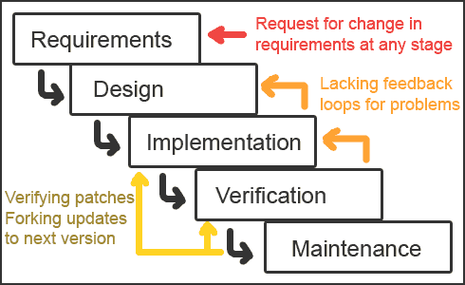

The waterfall model derivers its name due to the cascading effect from one phase to the other as is illustrated in above figure. In this model each phase well define starting and ending point, with identifiable deliveries to the next phase. Note that this model is sometime referred to as the linear sequential model or the software life cycle model. The water fall diagram is basically divided into following 5 models.

**Requirement**

**Design**

**Implementation**

**Verification**

**Maintenance**

* + **Requirement:-**

In the requirement phase the need to create the application is specified. What is the need of the system is defined. What information to be feeder to create the application will come under the requirement phase?

* + **Design:**

After the requirement phase the next phase is the Design phase where the application is designed according to the forms and other modules created. This phase is much important phase because it will structure the layout of your application.

* + **Implementation:**

Implementation is the process of having a system personnel phase check out and put new equipment into use, train users, install new application and construct any file of data need to use it.

* + **Verification:**

After the whole application is being the developed the main phase is the verification phase where the whole application tested and verified to check the whole application.

* + **Maintenance:**

After the successful verification of the application the main phase is the maintenance phase where the application needs to be maintained for its successful operation in future.

**Scope of the Project**

The proposed system will affect or interface with the person who visits in the park and administrator.

The system works and fulfills all the functionalities as per the proposed system.

It will provide reduced response time against the queries made by different users.

This project is based on PHP language with MYSQL database which manages people and provides ticket to the person who comes to visits in park with his/her family.

All possible features such as verification, validation, security, user friendliness etc have been considered.

**In this project there is one module i.e.**

**Admin**

Admin:

1. **Dashboard**: In this section, admin can see total entry ticket, normal entry tickets and water ride tickets.
2. **Pricing:** In this Section, admin can update the price of entry ticket , normal ride and water ride ticket.
3. **Entry Ticket:** In this section, admin can add, edit and delete the entry tickets.
4. **Ride Ticket**: In this section, admin can add, edit and delete the normal and water ride tickets.

Admin can also update his profile, change the password and recover the password.

**Software & Hardware requirements**

* Any Version of browser after Mozilla Firefox 4.0, Internet Explorer 6.0,chrome

**Hardware requirements:**

* Any processor after Pentium 4.
* Any version of Windows XP or later.
* Processor speed: 2.0 GHz
* RAM : 1GB
* Hard disk: 40GB to 80 GB

**Software requirements:**

* Database : MySQL
* Server : Apache
* Frontend : HTML
* Scripting Language : JavaScript
* IDE : Sublime
* Technology : PHP

**. OVERVIEW OF THE LANGUAGE USED**

***5.1 About Html:-***

# UNDERSTANDING HTML

* HTML was originated by Tim Berners-Lee.
* HTML developed a few years ago as a subset of SGML (Standard Generalized Mark-up Language), which is a higher-level mark-up language that has long been a favorite of the Department of Defense.
* Any HTML document is also valid for SGML.
* HTML is a Hyper Text Markup Language that is used to develop web pages.
* HTML is not a programming language like C, C++ and Java etc.
* It is a cross platform markup language that is design to be flexible enough to display text and other elements like graphical on a variety of views.
* The HTML documents consists of special Tags that are embedded in an ASCII document.
* Web browser like Internet Explorer, Netscape Navigator etc, interprets these Tags.

## Basic HTML

|  |  |
| --- | --- |
| **Tag** | **Description** |
| [<!DOCTYPE>](https://www.w3schools.com/tags/tag_doctype.asp) | Defines the document type |
| [<html>](https://www.w3schools.com/tags/tag_html.asp) | Defines an HTML document |
| [<head>](https://www.w3schools.com/tags/tag_head.asp)  Defines information about the document  [<title>](https://www.w3schools.com/tags/tag_title.asp)  Defines a title for the document | |
| [<body>](https://www.w3schools.com/tags/tag_body.asp) | Defines the document's body |
| [<h1> to <h6>](https://www.w3schools.com/tags/tag_hn.asp) | Defines HTML headings |
| [<p>](https://www.w3schools.com/tags/tag_p.asp) | Defines a paragraph |
| [<br>](https://www.w3schools.com/tags/tag_br.asp) | Inserts a single line break |
| [<hr>](https://www.w3schools.com/tags/tag_hr.asp) | Defines a thematic change in the content |
| [<!--...-->](https://www.w3schools.com/tags/tag_comment.asp) | Defines a comment |

## Formatting

|  |  |
| --- | --- |
| **Tag** | **Description** |
| [<abbr>](https://www.w3schools.com/tags/tag_abbr.asp) | Defines an abbreviation or an acronym |
| [<address>](https://www.w3schools.com/tags/tag_address.asp) | Defines contact information for the author/owner of a document/article |
| [<b>](https://www.w3schools.com/tags/tag_b.asp) | Defines bold text |
| [<bdi>](https://www.w3schools.com/tags/tag_bdi.asp) | Isolates a part of text that might be formatted in a different direction from other text outside it |
| [<bdo>](https://www.w3schools.com/tags/tag_bdo.asp) | Overrides the current text direction |
| [<blockquote>](https://www.w3schools.com/tags/tag_blockquote.asp) | Defines a section that is quoted from another source |
| [<cite>](https://www.w3schools.com/tags/tag_cite.asp) | Defines the title of a work |
| [<code>](https://www.w3schools.com/tags/tag_code.asp) | Defines a piece of computer code |
| [<del>](https://www.w3schools.com/tags/tag_del.asp) | Defines text that has been deleted from a document |
| [<dfn>](https://www.w3schools.com/tags/tag_dfn.asp) | Represents the defining instance of a term |
| [<em>](https://www.w3schools.com/tags/tag_em.asp) | Defines emphasized text |
| [<i>](https://www.w3schools.com/tags/tag_i.asp) | Defines a part of text in an alternate voice or mood |
| [<ins>](https://www.w3schools.com/tags/tag_ins.asp) | Defines a text that has been inserted into a document |
| [<kbd>](https://www.w3schools.com/tags/tag_kbd.asp) | Defines keyboard input |
| [<mark>](https://www.w3schools.com/tags/tag_mark.asp) | Defines marked/highlighted text |
| [<meter>](https://www.w3schools.com/tags/tag_meter.asp) | Defines a scalar measurement within a known range (a gauge) |
| [<pre>](https://www.w3schools.com/tags/tag_pre.asp) | Defines preformatted text |
| [<progress>](https://www.w3schools.com/tags/tag_progress.asp) | Represents the progress of a task |
| [<q>](https://www.w3schools.com/tags/tag_q.asp) | Defines a short quotation |
| [<rp>](https://www.w3schools.com/tags/tag_rp.asp) | Defines what to show in browsers that do not support ruby annotations |
| [<rt>](https://www.w3schools.com/tags/tag_rt.asp) | Defines an explanation/pronunciation of characters (for East Asian typography) |
| [<ruby>](https://www.w3schools.com/tags/tag_ruby.asp) | Defines a ruby annotation (for East Asian typography) |
| [<s>](https://www.w3schools.com/tags/tag_s.asp) | Defines text that is no longer correct |
| [<samp>](https://www.w3schools.com/tags/tag_samp.asp) | Defines sample output from a computer program |
| [<small>](https://www.w3schools.com/tags/tag_small.asp) | Defines smaller text |
| [<strong>](https://www.w3schools.com/tags/tag_strong.asp) | Defines important text |
| [<sub>](https://www.w3schools.com/tags/tag_sub.asp) | Defines subscripted text |
| [<sup>](https://www.w3schools.com/tags/tag_sup.asp) | Defines superscripted text |
| [<template>](https://www.w3schools.com/tags/tag_template.asp) | Defines a template |
| [<time>](https://www.w3schools.com/tags/tag_time.asp) | Defines a date/time |
| [<u>](https://www.w3schools.com/tags/tag_u.asp) | Defines text that should be stylistically different from normal text |
| [<var>](https://www.w3schools.com/tags/tag_var.asp) | Defines a variable |
| [<wbr>](https://www.w3schools.com/tags/tag_wbr.asp) | Defines a possible line-break |

**Forms and Input**

|  |  |  |
| --- | --- | --- |
| **Tag** | | **Description** |
| [<form>](https://www.w3schools.com/tags/tag_form.asp) | | Defines an HTML form for user input |
| [<input>](https://www.w3schools.com/tags/tag_input.asp) | | Defines an input control |
| [<textarea>](https://www.w3schools.com/tags/tag_textarea.asp) | | Defines a multiline input control (text area) |
| [<button>](https://www.w3schools.com/tags/tag_button.asp) | | Defines a clickable button |
| [<select>](https://www.w3schools.com/tags/tag_select.asp) | | Defines a drop-down list |
| [<optgroup>](https://www.w3schools.com/tags/tag_optgroup.asp) | | Defines a group of related options in a drop-down list |
| [<option>](https://www.w3schools.com/tags/tag_option.asp) | | Defines an option in a drop-down list |
| [<label>](https://www.w3schools.com/tags/tag_label.asp) | Defines a label for an <input> element |
| [<fieldset>](https://www.w3schools.com/tags/tag_fieldset.asp) | Groups related elements in a form |
| [<legend>](https://www.w3schools.com/tags/tag_legend.asp) | Defines a caption for a <fieldset> element |
| [<datalist>](https://www.w3schools.com/tags/tag_datalist.asp) | Specifies a list of pre-defined options for input controls |
| [<output>](https://www.w3schools.com/tags/tag_output.asp) | Defines the result of a calculation |

## Frames

|  |  |
| --- | --- |
| **Tag** | **Description** |
| [<iframe>](https://www.w3schools.com/tags/tag_iframe.asp) | Defines an inline frame |

## Images

|  |  |
| --- | --- |
| **Tag** | **Description** |
| [<img>](https://www.w3schools.com/tags/tag_img.asp) | Defines an image |
| [<map>](https://www.w3schools.com/tags/tag_map.asp) | Defines a client-side image-map |
| [<area>](https://www.w3schools.com/tags/tag_area.asp) | Defines an area inside an image-map |
| [<canvas>](https://www.w3schools.com/tags/tag_canvas.asp) | Used to draw graphics, on the fly, via scripting (usually JavaScript) |
| [<figcaption>](https://www.w3schools.com/tags/tag_figcaption.asp) | Defines a caption for a <figure> element |
| [<figure>](https://www.w3schools.com/tags/tag_figure.asp) | Specifies self-contained content |
| [<picture>](https://www.w3schools.com/tags/tag_picture.asp) | Defines a container for multiple image resources |
| [<svg>](https://www.w3schools.com/tags/tag_svg.asp) | Defines a container for SVG graphics |

## Audio / Video

|  |  |
| --- | --- |
| **Tag** | **Description** |
| [<audio>](https://www.w3schools.com/tags/tag_audio.asp) | Defines sound content |
| [<source>](https://www.w3schools.com/tags/tag_source.asp) | Defines multiple media resources for media elements (<video>, <audio> and <picture>) |
| [<track>](https://www.w3schools.com/tags/tag_track.asp) | Defines text tracks for media elements (<video> and <audio>) |
| [<video>](https://www.w3schools.com/tags/tag_video.asp) | Defines a video or movie |

|  |  |
| --- | --- |
| **Tag** | **Description** |
| [<ul>](https://www.w3schools.com/tags/tag_ul.asp) | Defines an unordered list |
| [<ol>](https://www.w3schools.com/tags/tag_ol.asp) | Defines an ordered list |
| [<li>](https://www.w3schools.com/tags/tag_li.asp) | Defines a list item |
| [<dl>](https://www.w3schools.com/tags/tag_dl.asp) | Defines a description list |
| [<dt>](https://www.w3schools.com/tags/tag_dt.asp) | Defines a term/name in a description list |
| [<dd>](https://www.w3schools.com/tags/tag_dd.asp) | Defines a description of a term/name in a description list |
| [<menu>](https://www.w3schools.com/tags/tag_menu.asp) | Defines a list/menu of commands |
| [<menuitem>](https://www.w3schools.com/tags/tag_menuitem.asp) | Defines a command/menu item that the user can invoke from a popup menu |

## Links

|  |  |
| --- | --- |
| **Tag** | **Description** |
| [<a>](https://www.w3schools.com/tags/tag_a.asp) | Defines a hyperlink |
| [<link>](https://www.w3schools.com/tags/tag_link.asp) | Defines the relationship between a document and an external resource (most used to link to style sheets) |
| [<nav>](https://www.w3schools.com/tags/tag_nav.asp) | Defines navigation links |

## Lists

## Tables

|  |  |
| --- | --- |
| **Tag** | **Description** |
| [<table>](https://www.w3schools.com/tags/tag_table.asp) | Defines a table |
| [<caption>](https://www.w3schools.com/tags/tag_caption.asp) | Defines a table caption |
| [<th>](https://www.w3schools.com/tags/tag_th.asp) | Defines a header cell in a table |
| [<tr>](https://www.w3schools.com/tags/tag_tr.asp) | Defines a row in a table |

## Styles and Semantics

|  |  |
| --- | --- |
| **Tag** | **Description** |
| [<style>](https://www.w3schools.com/tags/tag_style.asp) | Defines style information for a document |
| [<div>](https://www.w3schools.com/tags/tag_div.asp) | Defines a section in a document |
| [<span>](https://www.w3schools.com/tags/tag_span.asp) | Defines a section in a document |
| [<header>](https://www.w3schools.com/tags/tag_header.asp) | Defines a header for a document or section |
| [<footer>](https://www.w3schools.com/tags/tag_footer.asp) | Defines a footer for a document or section |
| [<main>](https://www.w3schools.com/tags/tag_main.asp) | Specifies the main content of a document |
| [<section>](https://www.w3schools.com/tags/tag_section.asp) | Defines a section in a document |
| [<article>](https://www.w3schools.com/tags/tag_article.asp) | Defines an article |
| [<aside>](https://www.w3schools.com/tags/tag_aside.asp) | Defines content aside from the page content |
| [<details>](https://www.w3schools.com/tags/tag_details.asp) | Defines additional details that the user can view or hide |
| [<dialog>](https://www.w3schools.com/tags/tag_dialog.asp) | Defines a dialog box or window |
| [<summary>](https://www.w3schools.com/tags/tag_summary.asp) | Defines a visible heading for a <details> element |
| [<data>](https://www.w3schools.com/tags/tag_data.asp) | Links the given content with a machine-readable translation |

## Meta Info

|  |  |
| --- | --- |
| **Tag** | **Description** |
| [<head>](https://www.w3schools.com/tags/tag_head.asp) | Defines information about the document |
| [<meta>](https://www.w3schools.com/tags/tag_meta.asp) | Defines metadata about an HTML document |
| [<base>](https://www.w3schools.com/tags/tag_base.asp) | Specifies the base URL/target for all relative URLs in a document |

**System Design**

Design is the first step in the development phase for any techniques and principles for the purpose of defining a device, a process or system in sufficient detail to permit its physical realization.

Once the software requirements have been analyzed and specified the software design involves three technical activities - design, coding, implementation and testing that are required to build and verify the software.

The design activities are of main importance in this phase, because in this activity, decisions ultimately affecting the success of the software implementation and its ease of maintenance are made. These decisions have the final bearing upon reliability and maintainability of the system. Design is the only way to accurately translate the customer’s requirements into finished software or a system.

Design is the place where quality is fostered in development. Software design is a process through which requirements are translated into a representation of software. Software design is conducted in two steps. Preliminary design is concerned with the transformation of requirements into data

**Unified Modelling Language Diagrams (UML):**

* + The unified modelling language allows the software engineer to express an analysis model using the modelling notation that is governed by a set of syntactic semantic and pragmatic rules.
  + A UML system is represented using five different views that describe the system from distinctly different perspective. Each view is defined by a set of diagram, which is as follows.

**User Model View**

* + 1. This view represents the system from the users perspective.
    2. The analysis representation describes a usage scenario from the end-users perspective**.**

**Structural model view**

◆In this model the data and functionality are arrived from inside the system.

◆ This model view models the static structures.

**Behavioural Model View**

◆ It represents the dynamic of behavioural as parts of the system, depicting the interactions of collection between various structural elements described in the user model and structural model view.

**Implementation Model View**

* + In this the structural and behavioural as parts of the system are represented as they are to be built.

**Environmental Model View**

In this the structural and behavioural aspects of the environment in which the system is to be implemented are represented.

UML is specifically constructed through two different domains they are

* + UML Analysis modelling, which focuses on the user model and structural model views of the system?
  + UML design modelling, which focuses on the behavioural modelling, implementation modelling and environmental model views**.**

### Use Case Diagrams Admin

#### ENTITY-RELATIONSHIP Diagrams

E-R (Entity-Relationship) Diagram is used to represents the relationship between entities in the table.

## The symbols used in E-R diagrams are:

SYMBOL PURPOSE

Represents Entity sets.

Represent attributes.

Represent Relationship Sets.

Line represents flow

Structured analysis is a set of tools and techniques that the analyst.

To develop a new kind of a system:

The traditional approach focuses on the cost benefit and feasibility analysis, Project management, and hardware and software selection a personal considerations.

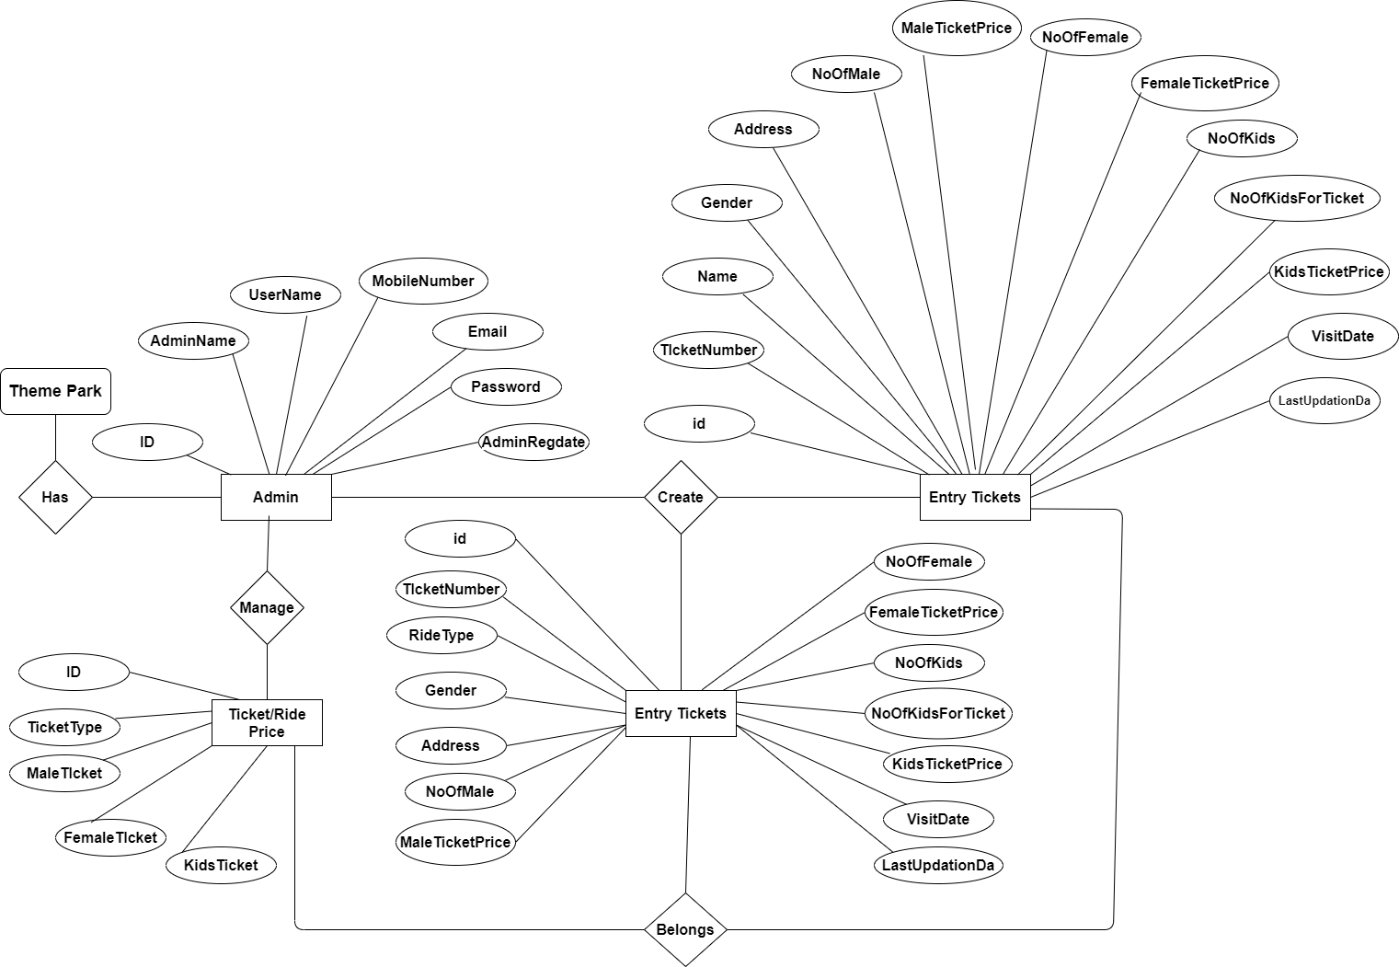

**DATABASE DESIGN**

The data in the system has to be stored and retrieved from database. Designing the database is part of system design. Data elements and data structures to be stored have been identified at analysis stage. They are structured and put together to design the data storage and retrieval system.

A database is a collection of interrelated data stored with minimum redundancy to serve many users quickly and efficiently. The general objective is to make database access easy, quick, inexpensive and flexible for the user. Relationships are established between the data items and unnecessary data items are removed. Normalization is done to get an internal consistency of data and to have minimum redundancy and maximum stability. This ensures minimizing data storage required, minimizing chances of data inconsistencies and optimizing for updates. The MS Access database has been chosen for developing the relevant databases.

**Theme Park Management System (PTMS) contains 4 MySQL tables :**

**tbladmin table Structure :** This table store the admin login and personal Details.

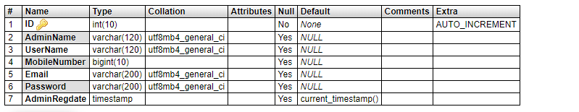

**tblprice table Structure :** This table stores entry, normal ride and water ride tickets price.

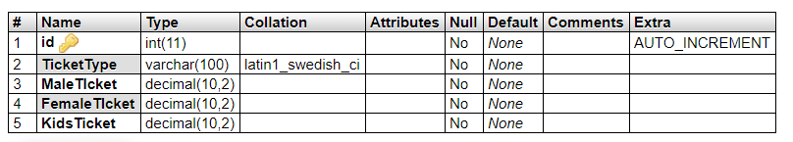

**tblentrytickets table Structure :** This table stores entry ticket detail.

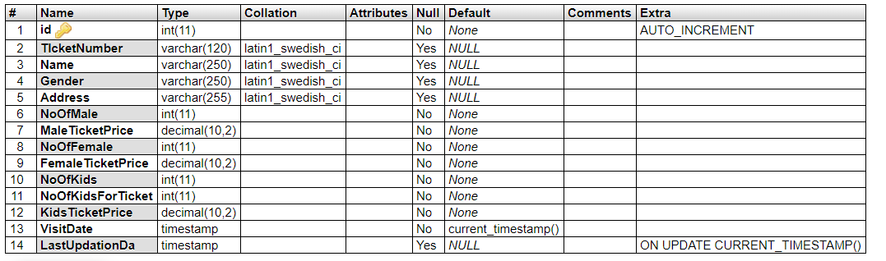

**tblridetickets table Structure :** This table stores normal and water ride ticket detail.

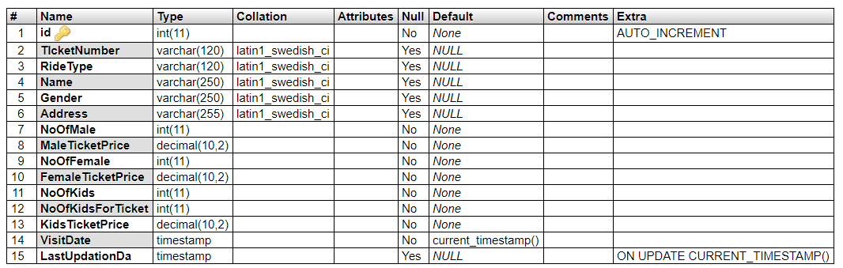

**Class Diagram:**

The class diagram shows a set of classes, interfaces, collaborations and their relationships.

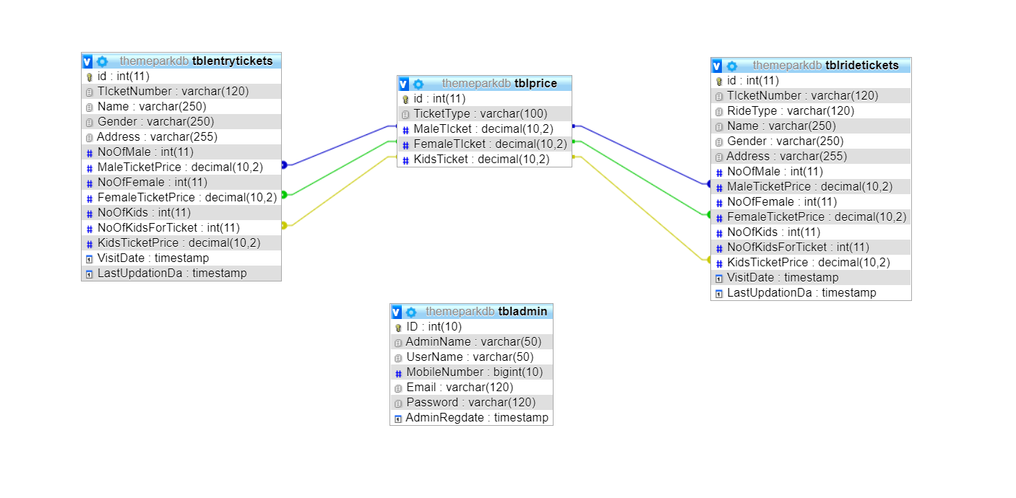

**SYSTEM TESTING**

**SOFTWARE TESTING TECHNIQUES:**

Software testing is a critical element of software quality assurance and represents the ultimate review of specification, designing and coding.

**TESTING OBJECTIVES:**

1. Testing is process of executing a program with the intent of finding an error.
2. A good test case design is one that has a probability of finding an as yet undiscovered error.
3. A successful test is one that uncovers an as yet undiscovered error.

These above objectives imply a dramatic change in view port.

Testing cannot show the absence of defects, it can only show that software errors are present.

There are three types of testing strategies

1. Unit test
2. Integration test

3. Performance test

**Unit Testing:**

Unit testing focuses verification efforts on the smallest unit of software design module. The unit test is always white box oriented. The tests that occur as part of unit testing are testing the module interface, examining the local data structures, testing the boundary conditions, execution all the independent paths and testing error-handling paths.

**Integration Testing:**

Integration testing is a systematic technique or construction the program structure while at the same time conducting tests to uncover errors associated with interfacing. Scope of testing summarizes the specific functional, performance, and internal design characteristics that are to be tested. It employs top-down testing and bottom-up testing methods for this case.

**Performance Testing:**

Timing for both read and update transactions should be gathered to determine whether system functions are being performed in an acceptable timeframe.

1. **CODING**

First phase of implementation is coding. Coding can be done in two ways. One by automatic program code and other by programmer’s manually written code. A code generator is a suite of programs that matches the input to an appropriate code template and from these produces modules of code.

The code is made simple in such a way that another programmer can easily understand and work on that in future. The crucial phase in the system development life cycle is the successful implementation of the new system design. The process of converting as new or revised system into an operational one is known as system implementation.

This includes all those activities that take place to convert from an old system to a new system. The system can be implemented only after a through testing is done and if it is found to work according to the specifications. The most crucial stage in achieving a new successful system and giving confident on the new system for the users is that it will work effectively and efficiently. If involves careful planning, investigation of the current system and its constraints on implementation, design of methods to achieve the change over.

Index.php

<?php

session_start();

error_reporting(0);

include('includes/config.php');

?>

<!DOCTYPE HTML>

<html>

<head>

<title>Amousement Park | BANGALORE</title>

<meta name="viewport" content="width=device-width, initial-scale=1">

<meta http-equiv="Content-Type" content="text/html; charset=utf-8" />

<script type="applijewelleryion/x-javascript"> addEventListener("load", function() { setTimeout(hideURLbar, 0); }, false); function hideURLbar(){ window.scrollTo(0,1); } </script>

<link href="css/bootstrap.css" rel='stylesheet' type='text/css' />

<link href="css/style.css" rel='stylesheet' type='text/css' />

<link href='//fonts.googleapis.com/css?family=Open+Sans:400,700,600' rel='stylesheet' type='text/css'>

<link href='//fonts.googleapis.com/css?family=Roboto+Condensed:400,700,300' rel='stylesheet' type='text/css'>

<link href='//fonts.googleapis.com/css?family=Oswald' rel='stylesheet' type='text/css'>

<link href="css/font-awesome.css" rel="stylesheet">

<!-- Custom Theme files -->

<script src="js/jquery-1.12.0.min.js"></script>

<script src="js/bootstrap.min.js"></script>

<!--animate-->

<link href="css/animate.css" rel="stylesheet" type="text/css" media="all">

<script src="js/wow.min.js"></script>

<script>

new WOW().init();

</script>

<!--//end-animate-->

</head>

<body>

<?php include('includes/header.php');?>

<div class="banner">

<div class="container">

<h1 class="wow zoomIn animated animated" data-wow-delay=".5s" style="visibility: visible; animation-delay: 0.5s; animation-name: zoomIn;"> Amousement Park - Bangalore </h1>

</div>

</div>

<!--- rupes ---->

<div class="container">

<div class="rupes">

<div class="col-md-4 rupes-left wow fadeInDown animated animated" data-wow-delay=".5s" style="visibility: visible; animation-delay: 0.5s; animation-name: fadeInDown;">

<div class="rup-left">

<a href="offers.html"><i class="fa fa-rupes"></i></a>

</div>

<div class="rup-rgt">

<h3>UP TO RS. 50 OFF</h3>

<h4><a href="offers.html">LIVE SMART</a></h4>

</div>

<div class="clearfix"></div>

</div>

<div class="col-md-4 rupes-left wow fadeInDown animated animated" data-wow-delay=".5s" style="visibility: visible; animation-delay: 0.5s; animation-name: fadeInDown;">

<div class="rup-left">

<a href="offers.html"><i class="fa fa-h-square"></i></a>

</div>

<div class="rup-rgt">

<h3>UP TO 70% OFF</h3>

<h4><a href="offers.html">ON HOTELS </a></h4>

</div>

<div class="clearfix"></div>

</div>

<div class="col-md-4 rupes-left wow fadeInDown animated animated" data-wow-delay=".5s" style="visibility: visible; animation-delay: 0.5s; animation-name: fadeInDown;">

<div class="rup-left">

<a href="offers.html"><i class="fa fa-mobile"></i></a>

</div>

<div class="rup-rgt">

<h3>FLAT USD. 50 OFF</h3>

<h4><a href="offers.html">US APP OFFER</a></h4>

</div>

<div class="clearfix"></div>

</div>

</div>

</div>

<!--- /rupes ---->

<div class = "content"><!--body content holder-->

<div class = "container">

<div class = "col-md-12"><!--body content title holder with 12 grid columns-->

<h1 class="weha">What we have</h1><!--body content title-->

</div>

</div>

<div class="container">

<div class="col-md-12">

<hr>

</div>

</div>

<div class="row"><!--wedding content-->

<section>

<div class="container">

<div class="col-md-6"><!--image holder with 6 grid columns-->

<img src="images/party1.jpg" class="img-responsive">

</div>

<div class="subcontent col-md-6"><!--Text holder with 6 column grid-->

<h1>Water Park</h1><!--title-->

<p><!--content-->

The most important day in a couple's life.

Guaranteeing personalized solutions and flawless execution, our venues provide the perfect

location for your special day.

</p>

</div><!--subcontent div-->

</div><!--container div-->

</section>

</div><!--row div-->

<div class="container">

<div class="col-md-12">

<hr>

</div>

</div>

<div class="row">

<section>

<div class="container">

<div class="col-md-6"><!--image holder with 6 grid columns-->

<img src="images/party2.jpg" class="img-responsive">

</div>

<div class="subcontent col-md-6"><!--Text holder with 6 column grid-->

<h1>Birthday Party</h1><!--title-->

<p><!--content-->

Whether an all-day or the ultimate extravaganza that

lasts well into the wee hours, our Urban Events team is here to make sure all your birthday

party wishes come true so you can kick back, drink up and enjoy your special day!

</p>

</div><!--subcontent div-->

</div><!--container div-->

</section>

</div><!--row div-->

<div class="container">

<div class="col-md-12">

<hr>

</div>

</div>

<div class="row">

<section>

<div class="container">

<div class="col-md-6"><!--image holder with 6 grid columns-->

<img src="images/party3.jpg" class="img-responsive">

</div>

<div class="subcontent col-md-6"><!--Text holder with 6 column grid-->

<h1>Fashion</h1><!--title-->

<p><!--content-->

Fast becoming to go-to location for fashion events, PR gatherings and product launches,

The Urban Purveyor Group venues provide you with choice and quality in premium locations

for all your event needs.

</p>

</div><!--subcontent div-->

</div><!--container div-->

</section>

</div><!--row div-->

<div class="container">

<div class="col-md-12">

<hr>

</div>

</div>

<div class="row">

<section>

<div class="container">

<div class="col-md-6"><!--image holder with 6 grid columns-->

<img src="images/party4.jpg" class="img-responsive">

</div>

<div class="subcontent col-md-6"><!--Text holder with 6 column grid-->

<h1>Meeting</h1><!--title-->

<p><!--content-->

From formal, to not-so-formal, our flexible event

spaces can cater to your every need for meetings and conferences large or small, and our

dedicated event team can assist with all aspects of your event planning.

</p>

</div><!--subcontent div-->

</div><!--container div-->

</section>

</div><!--row div-->

</div><!--body content div-->

</div>

<!---holiday---->

<div class="container">

<div class="holiday">

<h3>Package List</h3>

<?php $sql = "SELECT * from tbltourpackages order by rand() limit 4";

$query = $dbh->prepare($sql);

$query->execute();

$results=$query->fetchAll(PDO::FETCH_OBJ);

$cnt=1;

if($query->rowCount() > 0)

{

foreach($results as $result)

{ ?>

<div class="rom-btm">

<div class="col-md-3 room-left wow fadeInLeft animated" data-wow-delay=".5s">

<img src="admin/pacakgeimages/<?php echo htmlentities($result->PackageImage);?>" class="img-responsive" alt="">

</div>

<div class="col-md-6 room-midle wow fadeInUp animated" data-wow-delay=".5s">

<h4>Package Name: <?php echo htmlentities($result->PackageName);?></h4>

<h6>Package Type : <?php echo htmlentities($result->PackageType);?></h6>

<p><b>Package Location :</b> <?php echo htmlentities($result->PackageLocation);?></p>

<p><b>Features</b> <?php echo htmlentities($result->PackageFetures);?></p>

</div>

<div class="col-md-3 room-right wow fadeInRight animated" data-wow-delay=".5s">

<h5>RS <?php echo htmlentities($result->PackagePrice);?></h5>

<a href="package-details.php?pkgid=<?php echo htmlentities($result->PackageId);?>" class="view">Details</a>

</div>

<div class="clearfix"></div>

</div>

<?php }} ?>

<div><a href="package-list.php" class="view">View More Packages</a></div>

</div>

<div class="clearfix"></div>

</div>

<!--- routes ---->

<div class="routes">

<div class="container">

<div class="col-md-4 routes-left wow fadeInRight animated" data-wow-delay=".5s">

<div class="rou-left">

<a href="#"><i class="glyphicon glyphicon-list-alt"></i></a>

</div>

<div class="rou-rgt wow fadeInDown animated" data-wow-delay=".5s">

<h3>80000</h3>

<p>Enquiries</p>

</div>

<div class="clearfix"></div>

</div>

<div class="col-md-4 routes-left">

<div class="rou-left">

<a href="#"><i class="fa fa-user"></i></a>

</div>

<div class="rou-rgt">

<h3>1900</h3>

<p>Regestered users</p>

</div>

<div class="clearfix"></div>

</div>

<div class="col-md-4 routes-left wow fadeInRight animated" data-wow-delay=".5s">

<div class="rou-left">

<a href="#"><i class="fa fa-ticket"></i></a>

</div>

<div class="rou-rgt">

<h3>7,00,00,000+</h3>

<p>Booking</p>

</div>

<div class="clearfix"></div>

</div>

<div class="clearfix"></div>

</div>

</div>

<?php include('includes/footer.php');?>

<!-- signup -->

<?php include('includes/signup.php');?>

<!-- //signu -->

<!-- signin -->

<?php include('students/index.php');?>

<!-- //signin -->

<!-- write us -->

<?php include('includes/write-us.php');?>

<!-- //write us -->

</body>

</html>

**Output Screen of Project**

**Home Page**

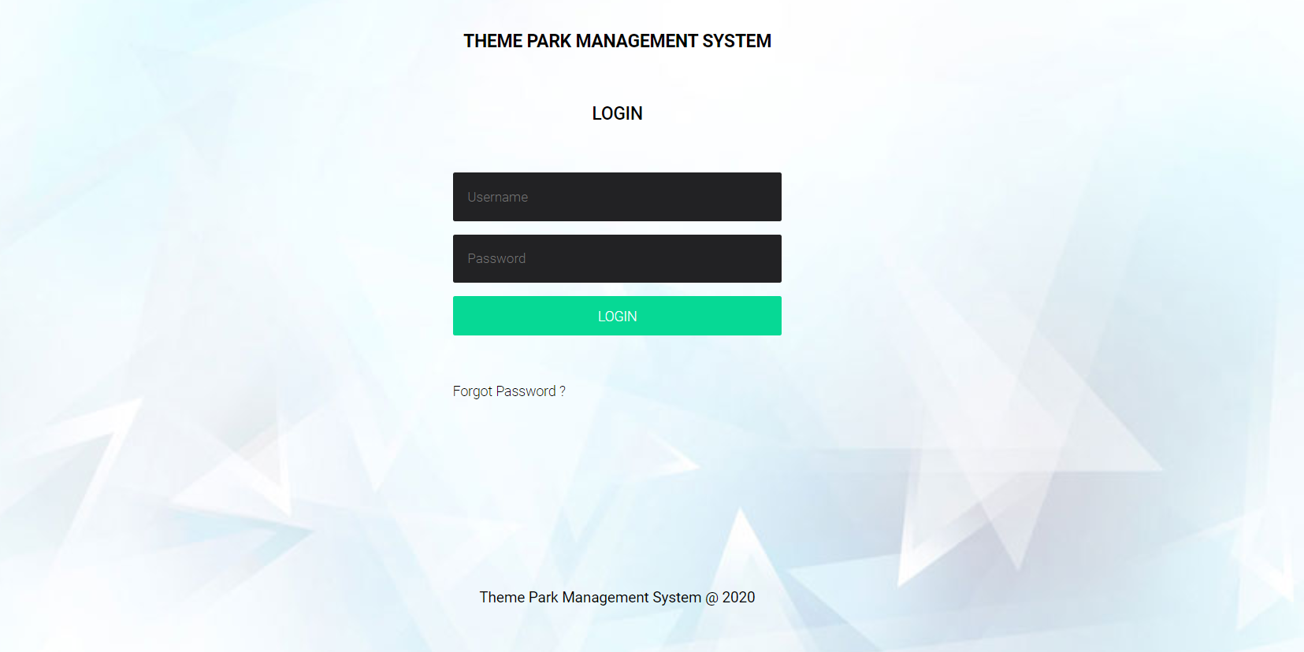

**Dashboard**

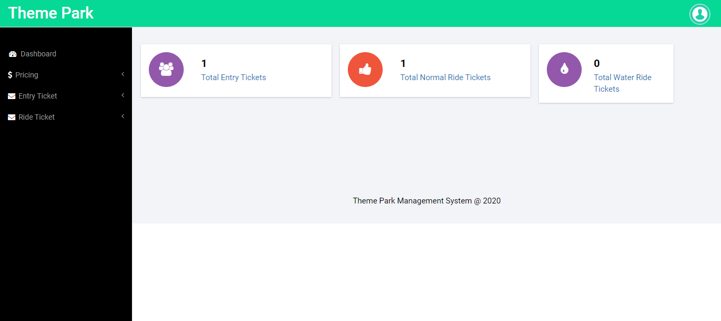

**Profile**

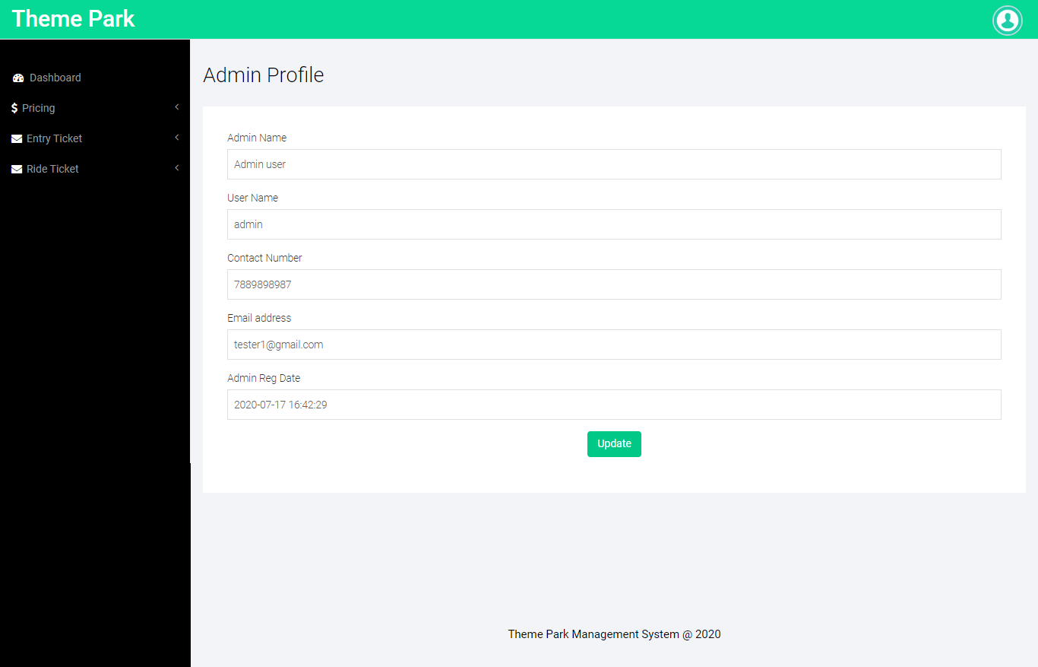

**Change Password**

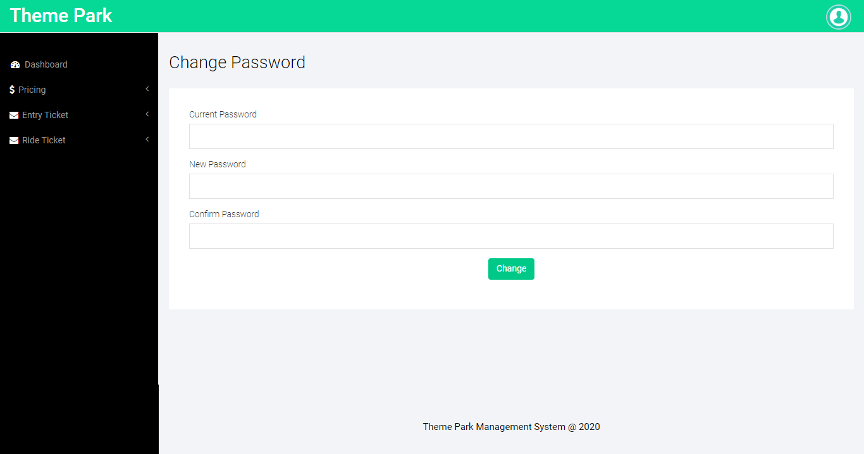

**Entry Price**

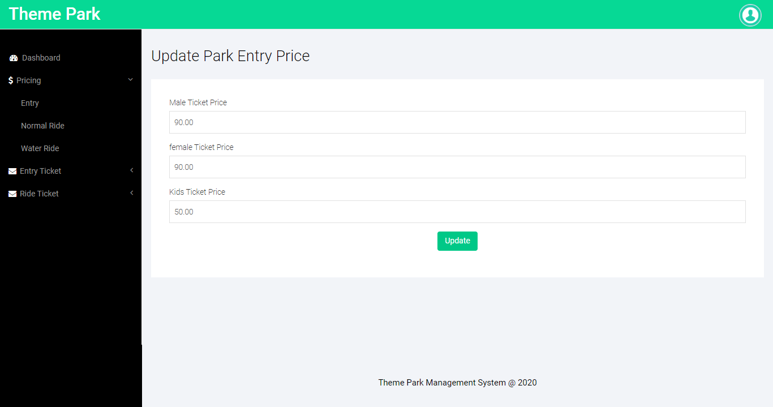

**Normal Ride Price**

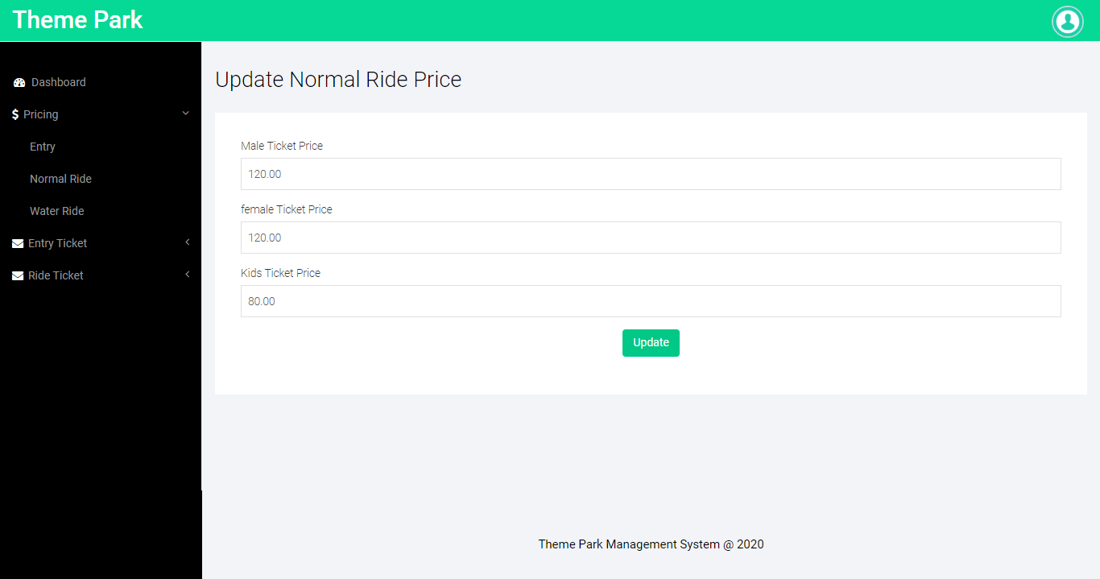

**Water Ride Price**

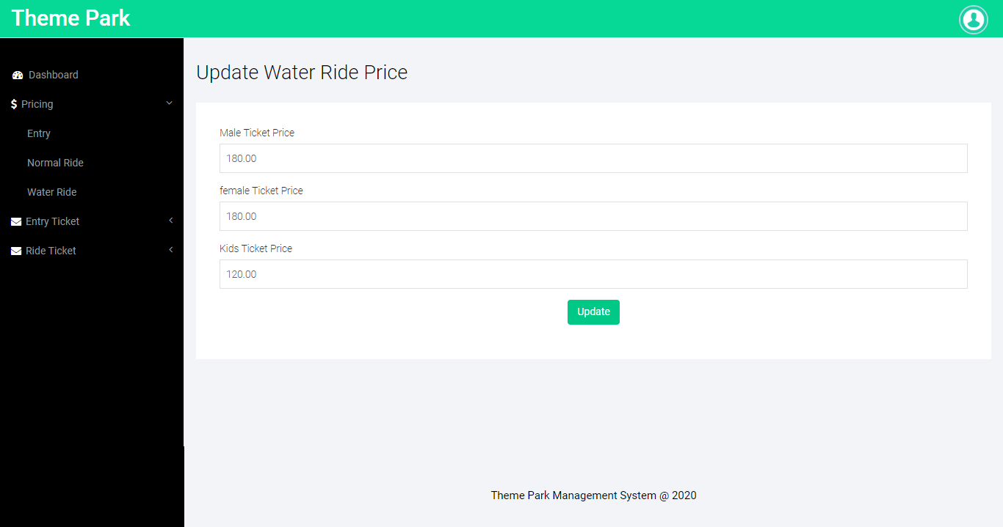

**Add Tickets**

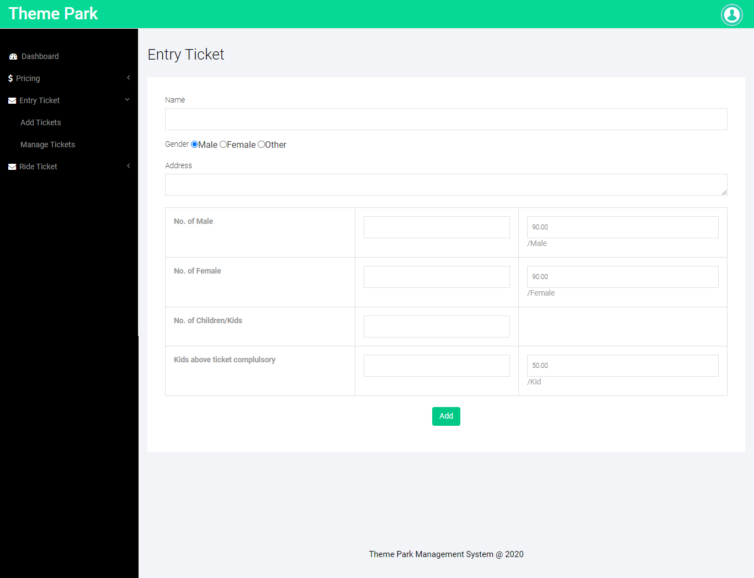

**Manage Entry Tickets**

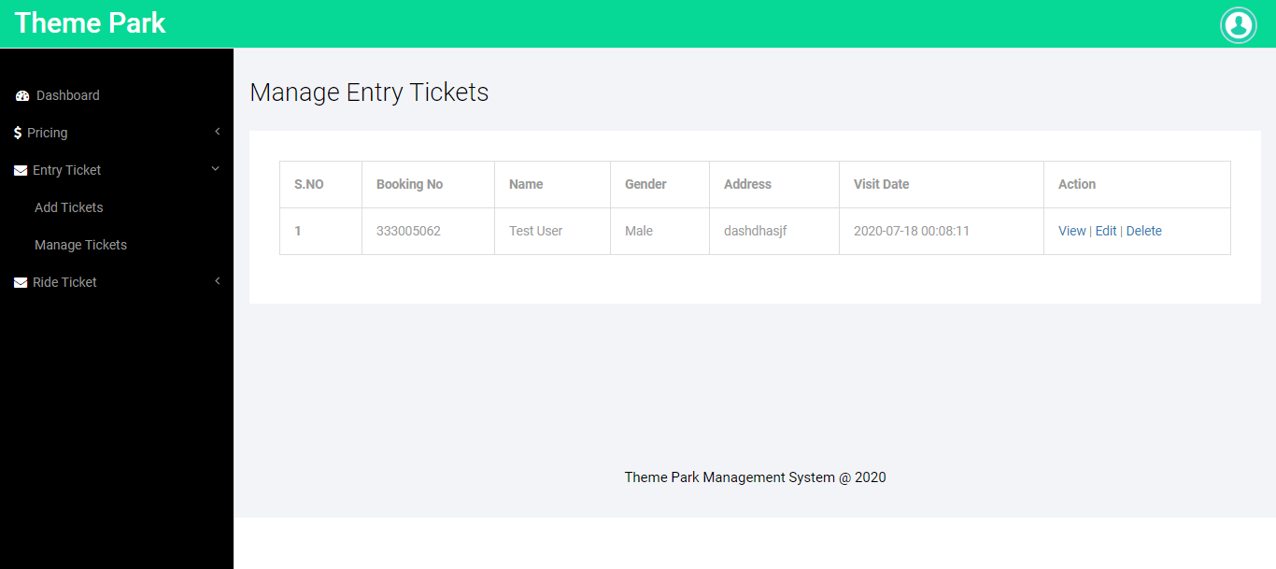

**View Entry Tickets**

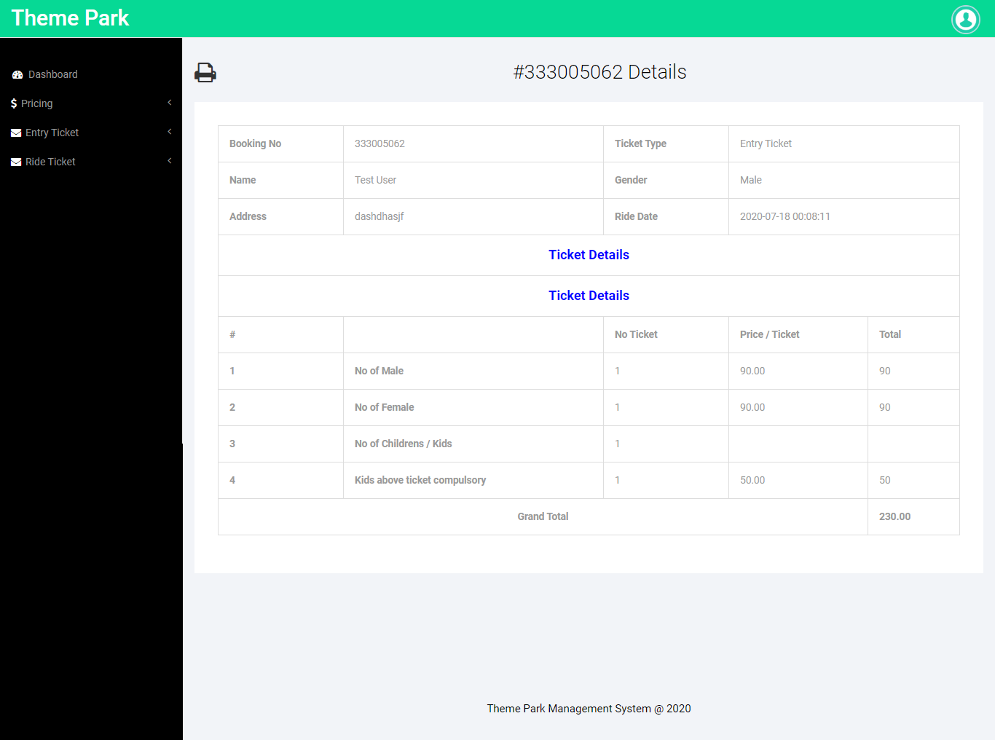

**Edit Entry Tickets**

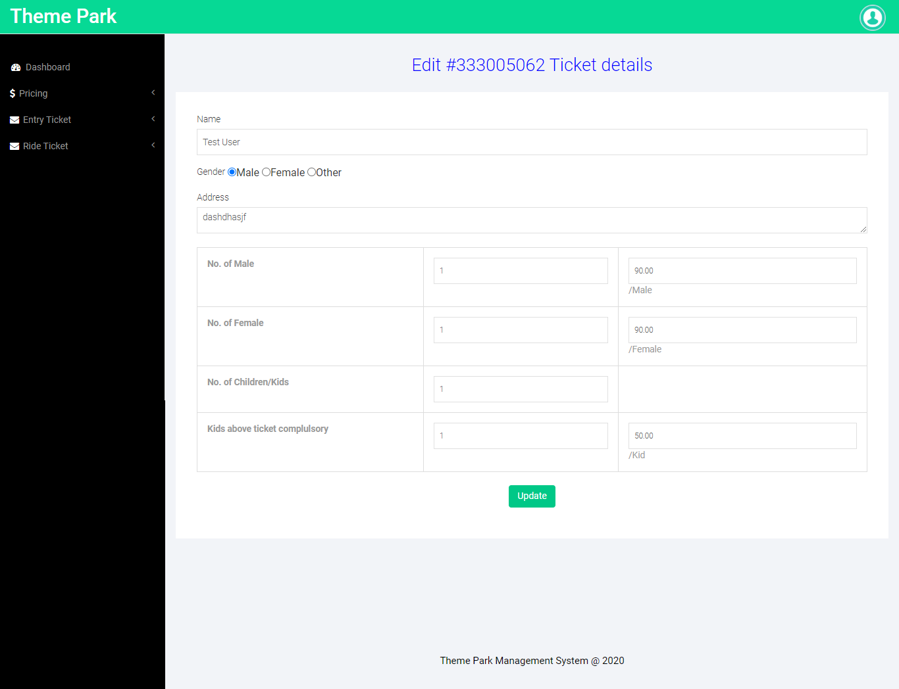

**Add Ride Tickets**

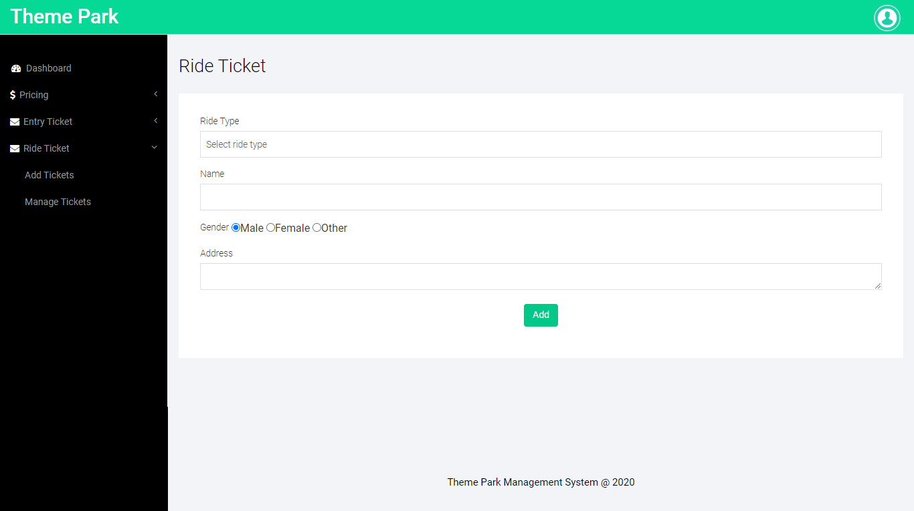

**Manage Ride Tickets**

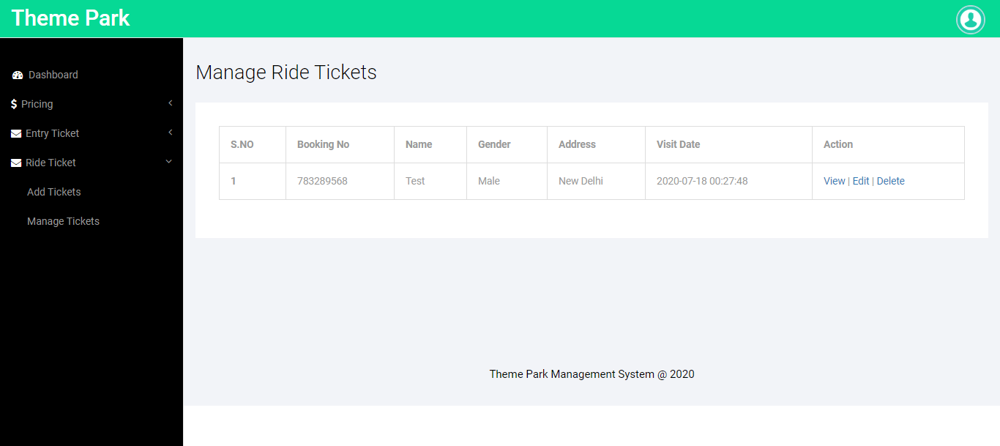

**View Ride Tickets**

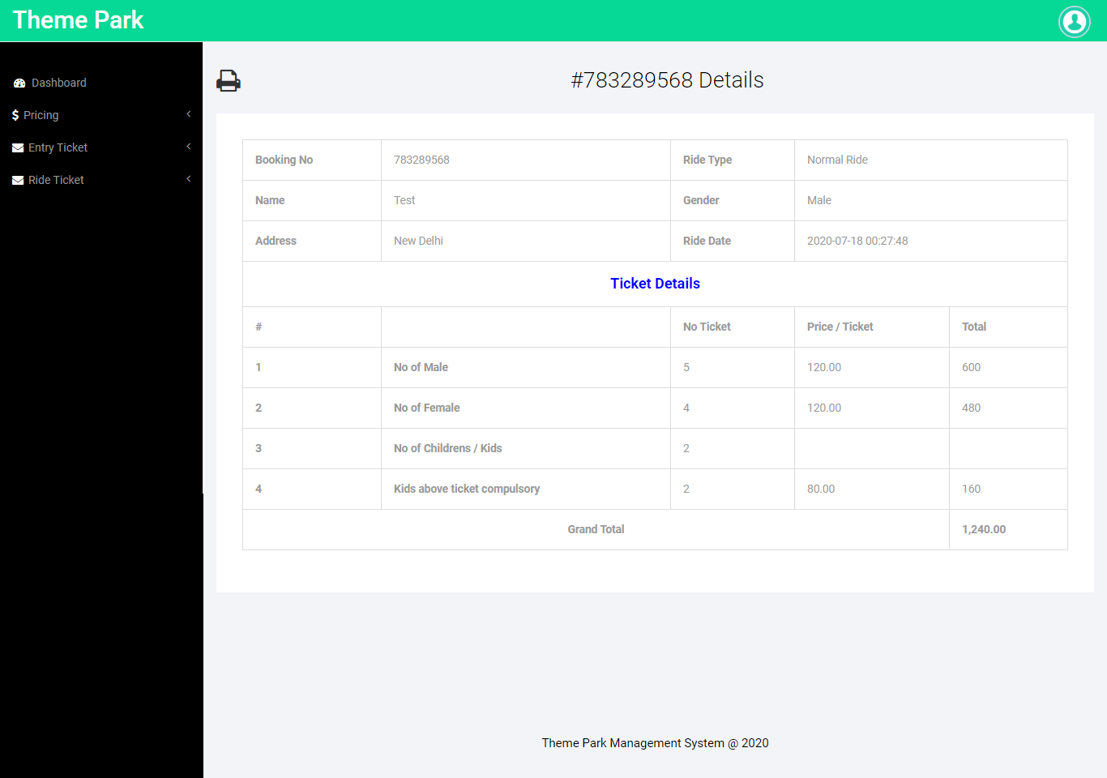

**Edit Ride Tickets**

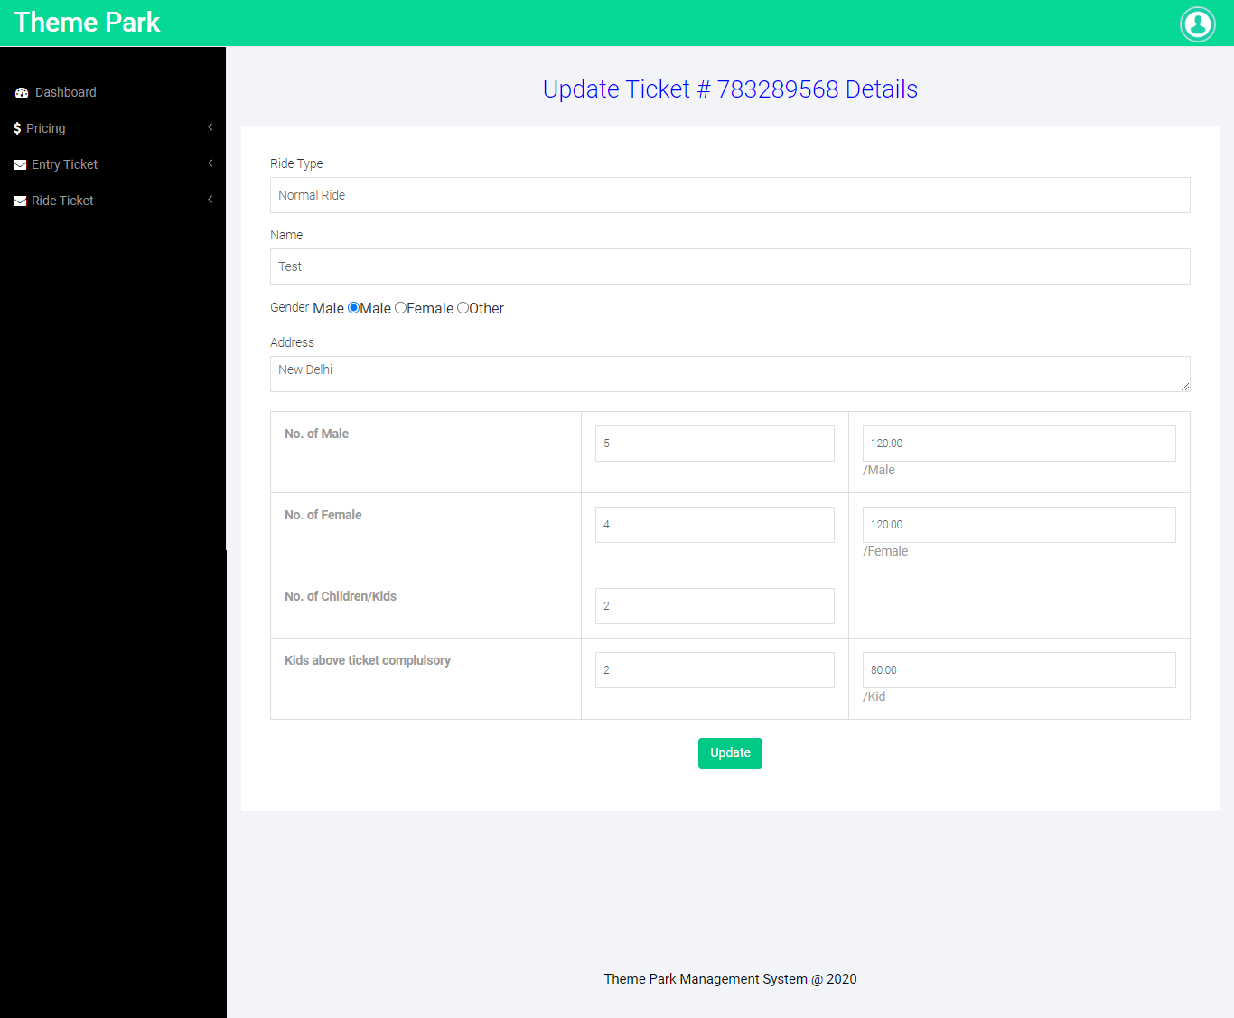

**Forgot Password**

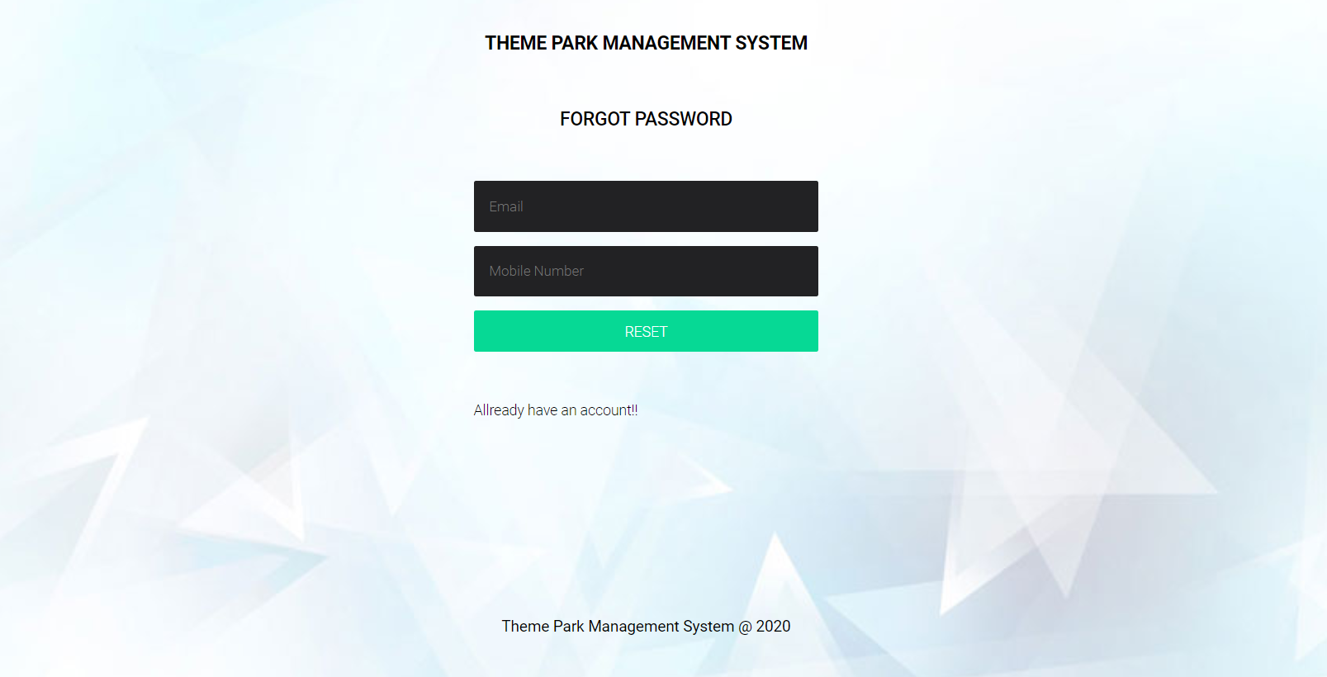

**Reset Password**

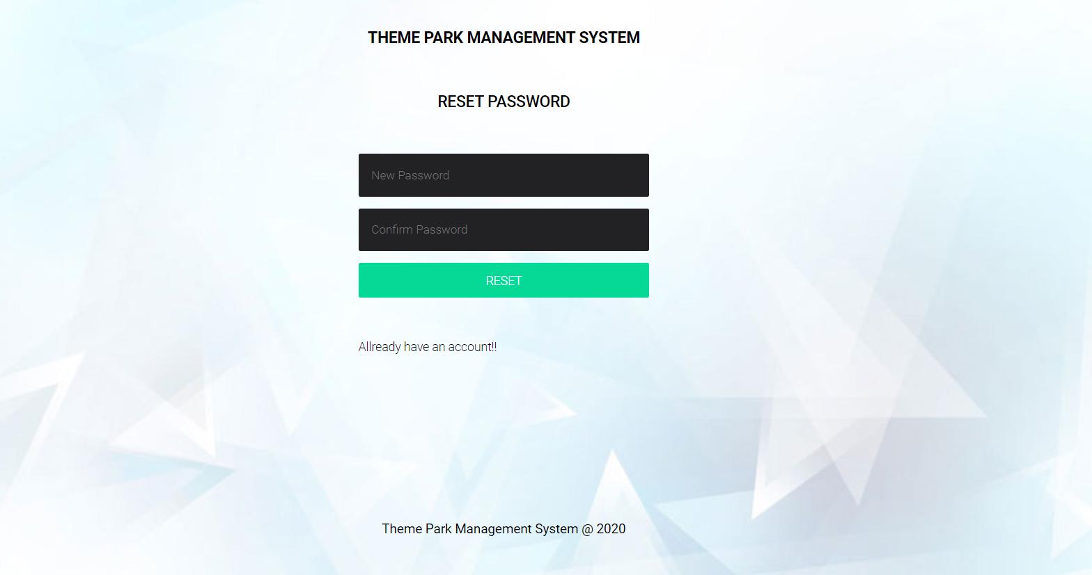

**Conclusion**

The project titled as **Theme Park Management System** was deeply studied and analyzed to design the code and implement. It was done under the guidance of the experienced project guide. All the current requirements and possibilities have been taken care during the project time.

**Theme Park Management System** is a web based application which manages and handles the people ticket who visited in the park.

**Bibliography**

**For PHP**

* <https://www.w3schools.com/php/default.asp>
* <https://www.sitepoint.com/php/>
* <https://www.php.net/>

**For MySQL**

* <https://www.mysql.com/>
* [http://www.mysqltutorial.org](http://www.mysqltutorial.org/)

**For XAMPP**

* <https://www.apachefriends.org/download.html>